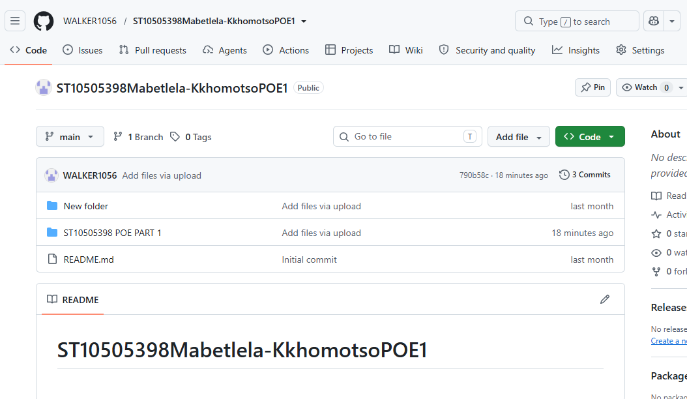

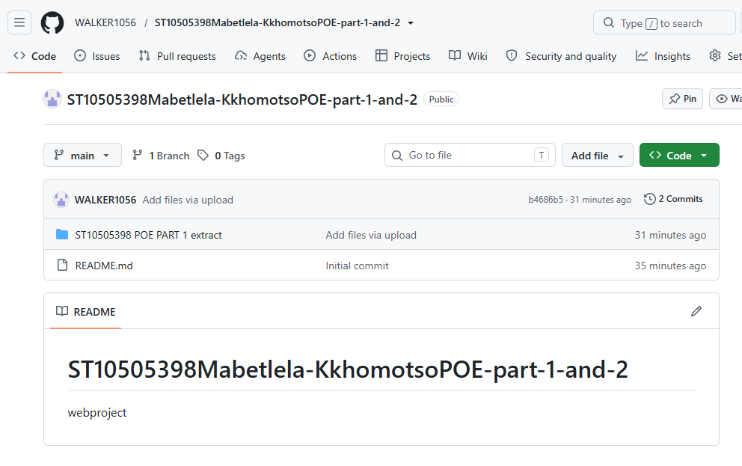
I have completed and uploaded part 1and 2 .I have created a public github repository to host my work.

According to Williams (2022, p. 112), adding CSS to an HTML document requires three things: linking the stylesheet, ensuring the HTML has proper structure, and adding hooks (classes and IDs) that CSS and JavaScript can target.
Krug (2014, p. 78) explains that HTML provides the structure (semantics), CSS provides the presentation (visual styling), and JavaScript provides the behaviour (interactivity). These three layers work together but stay separate — a principle known as "separation of concerns" (Nielsen, 2022, p. 156).
When CSS is added, the HTML must be adjusted so that
- The browser knows where to find the styles.
- Elements have identifiers that CSS can target.
- Interactive elements have the markup JavaScript needs.

1 | Added <link rel="stylesheet" href="css/style.css"> | Inside <head> of all 6 pages | External stylesheets are the recommended method for linking CSS to HTML (Chaffey and Ellis-Chadwick, 2019, p. 201). This keeps structure and presentation separate.
2 | Added <script src="js/main.js"></script> | Before </body> of all 6 pages | Placing scripts at the end of the body ensures the HTML loads first, preventing render-blocking (Williams, 2022, p. 134).
3 | Added hamburger button  <button class="nav-toggle"> | Inside header of all 6 pages | Mobile-first design requires a navigation pattern suited to small screens (Krug, 2014,

Chaffey, D. and Ellis-Chadwick, F. (2019) Digital marketing: strategy, implementation and practice. 7th edn. Harlow: Pearson.
Krug, S. (2014) Don't make me think, revisited: a common sense approach to web usability. 3rd edn. Berkeley: New Riders.
Nielsen, J. (2022) Usability engineering: user experience for the modern web. 2nd edn. New York: Morgan Kaufmann.
Williams, R. (2022) Web design for small businesses: a practical guide. Cape Town: African Publishers.

